SIR Foundation Summer Medical Student Internship Program
Proposal:

Institution Name: Johns Hopkins University
Division of Interventional Radiology
Responsible mentoring physician: Clifford Weiss, MD FSIR
Length of proposed curriculum: 8 weeks, 40 hours/week.
- Please provide a brief description of how each of the following curriculum elements will be demonstrated/taught through your program. Provide details of the instructional setting and methodology (laboratory, classroom), description of any educational resources (PowerPoint presentations, textbooks, selected readings), and assessment techniques (question and answer sessions, tests) to be used in the process of instruction:
  - Program Textbook –Abram’s Angiography: Interventional Radiology , editors JF Geschwind, Michael Dake, ( Lippincott Williams & Wilkins, 3rd Edition )
  - Required reading:
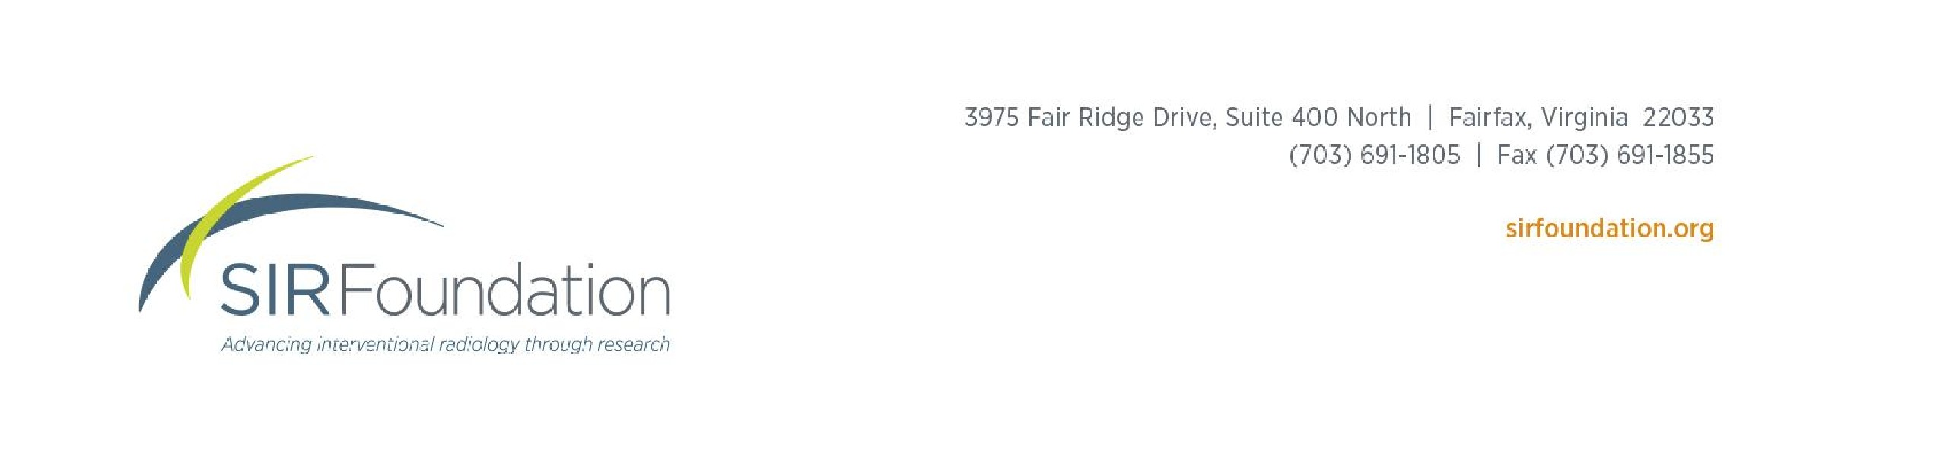
    - “Scientific Manuscripts”: ppt lecture delivered at 2011 SIR LEARN fellows spring practicum, A Nemcek (provided by SIR)

    - Bordage G, Review criteria for research manuscripts. Joint Task Force of Academic Medicine and the GEA-RIME Committee. Acad Med. 2001 Sep;76(9):897-978.
    - Provenzale JM, Stanley RJ. AJR Am J Roentgenol. 2005 Oct;185(4):848-54.A systematic guide to reviewing a manuscript.
  - Provided Education Resources: a PC computer and desk workspace will be provided to the student, which includes access to the Internet, as well as online electronic educational resources.

Mandatory elements:
  - Concept development –
The student will initially formulate an understanding of the clinical practice and procedural scope of a Vascular and Interventional Radiologist. This will serve as the initial 10-20% of the duration of the internship. The student will attend the IR Morning conference. The Morning business rounds will expose the student to the procedures and clinical spectrum that an interventional radiologist faces. Thereafter, the student will be assigned a supervising attending for each of the 5 days, where the student will immerse themselves to the VIR procedure room and function as a second assistant to each procedure. This will allow the student first hand exposure to potential clinical research questions. This “hands on” clinical instruction and research question hypothesis development will occur in the interventional radiology suites
  - Experimental design and statistics, including proof of concept, steps in validation of new technique:

The student will be working primarily on the topic of Bariatric Embolization. This will include working on an established animal model, as well as on clinical trials both underway and underdevelopment.

  - Techniques in the basic translational science lab/ clinical science labs
The student will be exposed to interventional radiology in a laboratory. Research is dedicated to translational and clinical research studies in obesity with a strong emphasis on experimental therapeutics.
  - Data collection, statistics, and meaningful analysis of data
The student will be directly supervised on a daily basis by the post-doctorate fellows and junior faculty members who are involved in the conduct of clinical trials. The student will observe the role played by the research coordinator as well as the regulatory coordinator and their importance in collecting data for clinical research. Pertinent introductory clinical statistical analysis will be taught by the faculty. Usage of statistical software such as STATA will be provided.
  - Constructing a well-written scientific paper
The award student will have direct instruction into the hallmarks of a well-balanced scientific manuscript by Dr. Weiss (currently Deputy Editor, Radiology). This will focus on a well thought out focused scientific question, coupled with a succinct introduction to the topic; a Materials & Method section that reflects the scientific work and Results section that details all pertinent findings stemming from the work. The Discussion section will tie the relevance of the study question to that already in the literature and ultimately answer the original scientific question.
The student’s own project will then be guided to follow this structure.
  - Suggested/optional elements:
a. Design and conduct of animal research and observation of animal research
The student will be introduced to animal pre-clinical research and clinical research and will spend 80-90% of the allocated time in the Interventional Radiology division. Instruction on the process of protocol development and implementation to test a research question will be provided by Dr. Weiss and/or the interventional radiology faculty.
The student will always be supervised by experienced post-doctoral fellows and/or junior faculty members.
- Please provide a brief outline of available research topics, one of which the student will select for completion as part of the program. Projects should be of a scope appropriate for completion within the limited time frame provided.
The student will have access to a number of research projects both clinical and translational.
    - Development of Angiographic Techniques for Bariatric Embolization. To develop minimally invasive techniques to treat patients with obesity. Current interests focus on Bariatric Embolization, Vagal Cryoablation, Bariatric Radioembolization, etc. (preclinical).
    - Bariatric Embolization Clinical Trials (in development)
    - Vascular Anomalies – Analysis of a 30-year database of vascular anomalies patients, development of AI for assessment MRIs to trac vascular malformations, QOL metrics for vascular malformations
    - Clinical trials in HHT and Vascular Malformations. This includes novel image guidance and therapeutics
    - Quantitative assessment of embolization endpoints – using a benchtop and preclinical model
    - Device development projects (BME or Engineering background is required)

All projects are highly collaborative and involve a multidisciplinary approach to translational/clinical research.

The student may be asked to make an oral presentation at the Medical Student Brunch at the SIR Annual Scientific Meeting, and will be encouraged to present their work at a national scientific conference, if applicable.

